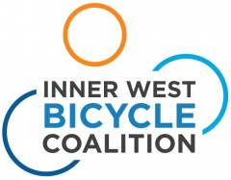
22/3/2018
Lilyfield Rd and Alternative East West Routes
Summary
- Lilyfield Rd will still be an important route for cyclists. Retain less contentious parts of the Lilyfield Rd cycleway plan and investigate other safety improvements.

- In addition, we recommend, as an alternative to Lilyfield Rd, using route EW05 on Allen and Moore Sts, then Catherine St to Lilyfield Rd or Brenan St/Railway Pde to The Crescent. Note that a variation to EW05, using Lyall St, is proposed to avoid a steep section on Allen St at darley Rd.
- Develop a gentle gradient route from the Bay Run to Allen St and Norton St via Francis St, for use as an alternative to Lilyfield Rd for eastbound cyclists.

- Link Fivedock and Haberfield to Allen St route via Waratah St and Barton St. Note the extended route links several suburbs and brings cyclists closer to Main Streets and schools. This could become part of the Regional Route from Parramatta.

- Westconnex plans for the Railyard will improve bicycle access to Anzac Bridge and provide new options.

- A new route for the City West Cycle Link tunnel under Leichhardt/Lilyfield is proposed.

Inner West Bicycle Coalition would welcome the opportunity to work with Council on developing improved east-west routes for cyclists.

Lilyfield Rd and Alternative East West Routes

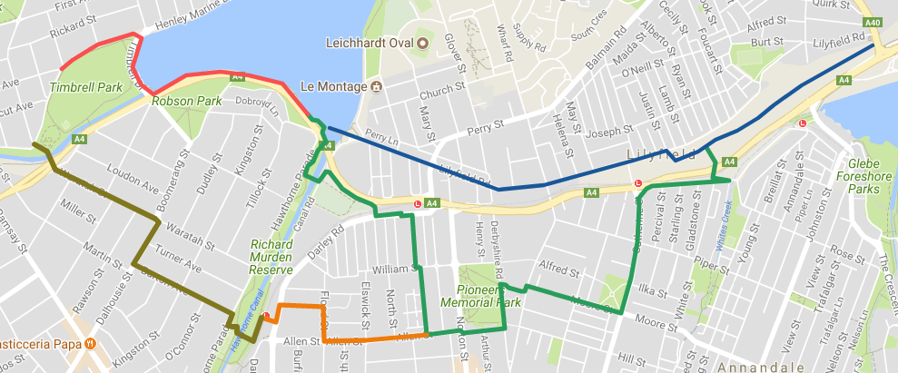
Fig 1. Lilyfield Rd in blue, Allen St in orange, Francis/Allen/Moore/Catherine in green. Bay Run in red. Extension to Haberfield and Fivedock in olive.

Refer to more detailed Google map on the link below
https://drive.google.com/open?id=1lqkvHxWyfkDY8YMkdQKk_19ec54y2QV5&usp=sharing_eil
(Zoom in or out to see more or less detail. Click on lines or markers for text. Select one or more layers.)
We suggest that, in line with the recent recommendations of the Council and Traffic Committee, Councillors, relevant staff and cycling groups meet to investigate alternatives to Lilyfield Rd but also which of the less contentious parts of the Lilyfield Rd concept plan could be retained, and which other measures could be taken to improve safety for cyclists and pedestrians. Lilyfield Rd will likely continue to be a major cycling route for more experienced or fitter/younger commuter cyclists and, as shown below, alternatives also use parts of Lilyfield Rd.
The parts of the concept plan retained could be:
1. The removal of parking between Gordon and Justin Sts (to allow for bike lanes on both sides of the road);
2. Widening of the road by relocating the southern gutter between Balmain Rd and Justin St , or removing parking (again to allow bike lanes on both sides of the road);
3. Making Lilyfield Rd one way west between Gordon and Victoria Rd, assuming this is less contentious than the other one way proposals, but noting that a proposed path in the Railyard might make a cycleway on this section of Lilyfield Rd redundant;
4. Removal of the slip lane at Mary St so that car parking outside businesses on the corner can be relocated to Mary St.

Other measures to be investigated could include:
- A consistent use of the uphill bike lane treatment.
- More use of Bicycles May Use Full Lane (BMUFL) signs, as currently on part of Lilyfield Rd.
- Improvements to pedestrian crossing at Catherine St and a new crossing of Norton St at Lilyfield Rd with raised platform, both to include a cyclist crossing.
- Speed limits and speed reduction devices.
- Indented parking or other measures at critical conflict points for cyclists, eg on bends.

The Google map identifies a number of possible alternatives to Lilyfield Rd, including one via the LAC and Mary St or Mary/Church/ Wharf Sts, and some via Callan Park to Cecily St. A route behind the sound wall of the City West Link is almost possible. Booth St/Moore St/Allen St is an existing east west route. The City West Cycle Link tunnel is another possible alternative. A route via Jarret and Albion using Dot Lane is also a possibility, but needs a connection to the Greenway in the west and Pyrmont Bridge rd in the east.

In our view, the best alternative East West route, one that serves Inner West residents and businesses, would be via the existing routes on Allen St and Moore St to Catherine St (orange and green lines on map above). This route, part of EW05 in the Leichhardt Bike Plan, has a high priority so we hope it will possible to justify retaining RMS funds and putting part towards this route.
We suggest a variation to EW05 at the Darley Rd end, to use Lyall and Flood Sts to avoid the steep hill on Allen and the roundabout with its heavy cross traffic on Darley Rd. There is already a path along Darley Rd from the light rail crossing to a refuge crossing at Lyall St. Lyall St is a dead end and is a quiet street, needing minimal bike treatment, thus avoiding controversy about bidirectional cycleways. This route can link with Dalhousie St in Haberfield via Barton St, and with Ingham St in Fivedock via Waratah St, thus forming an East West route connecting those major suburbs.
A side link (connecting the Bay Run to Allen St can be developed via Francis St and Canal Rd off Darley Rd at Charles St. This would be a gentle grade alternative to Lilyfield Rd. Francis St is a low traffic street due to a mid-block road closure.

The Allen St route crosses Norton St near a pedestrian crossing which could be modified to allow bicycles priority. The east end of Allen St is a low-traffic street due to the road closure at Norton St. The route then continues on Derbyshire Rd, another dead end street, behind the secondary college and comes out at the Moore St lights on Balmain Rd, where there is already a bicycle crossing for eastbound cyclists.
Whether the Waratah/Allen/Moore St route (plus Francis St) could be called a Regional Route is at least arguable. It would connect to Queen and Gipps St through Concord, which have been mentioned as possibilities for the Regional Route from Parramatta eventually. The combined Waratah/Allen and Francis/Allen St options bring cyclists closer to shops on Main Streets and schools and are therefore preferred. By chance, Allen St is wider than normal between Elswick St and Norton, so that wide bike lanes or a protected path may fit.
Moore St is a wide street and has bike lanes on both sides. These could be retained or a bi-directional cycleway could be provided on the north side of Moore St to Catherine St, thence on the existing bike route on Brenan St and Railway Pde to The Crescent, or continuing on Catherine St and crossing the City West Link to Lilyfield Rd at soon to be completed bicycle crossings. Moore/White St is an option eastbound, but doesn't work westbound. Note that the M4 East Project proposes a bridge across the CWL at Whites Ck, to a path in the railyard, so we have shown this in Fig 1.
Alternatively cyclists can continue north on the shared path on Balmain Rd past the Bus Depot to the City West Link. As noted in our submission on the Lilyfield Rd Cycleway, one of the major problems for cyclists is the lack of bicycle lights and crossings at the City West Link, and the constrictions on the western footpath on Balmain Rd at Lilyfield Rd, preventing its use as a shared path. If this problem section can be finally resolved a major missing link in our cycleway network can be provided. Use of the wide eastern footpath across the rail bridge for southbound cyclists or a road realignment should also be looked at.
Effect of Westconnex plan on the Railyards.
Two new bridges are proposed over the City West Link into the new Railyard park, at Whites Ck from Brenan St, and at The Crescent. A path is proposed from near Justin St to the Anzac Bridge approach, going under Victoria Rd. All these will provide more options for good access to the Anzac Bridge from The Allen St/Moore St route.
City West Cycle Link
The original route next to the rail line from Charles St to the Railyards east of Balmain Rd would involve closing the light rail to allow a machine to excavate a half tunnel into the rock face of the cutting. A new full tunnel not affecting the light rail line could be cut or bored directly from the foot of Lilyfield Rd at about Charles St through to rejoin Lilyfield Rd east of Balmain Rd near about Helena St, reducing the gradient considerably. A well lit 850m tunnel with CCTV would be safe and take only a few minutes to traverse. Examples of tunnels for cyclists exist in a number of places around the world, such as the 1.7 km Croix-Rousse Tunnel in Lyon and our own Fernleigh Track in Newcastle.
Given the equipment and resources available from the M4 East project a small extra tunnel for cyclists would seem entirely feasible.

Inner West Bicycle Coalition would welcome the opportunity to work with Council on developing a plan to provide improved east west access for cyclists across the Inner West.

Neil Tonkin
Advocacy Coordinator
Inner West Bicycle Coalition
39 The Boulevarde
Lilyfield
Mob 0409313008
Email neil.tonkin@ozemail.com.au

22/3/2018

